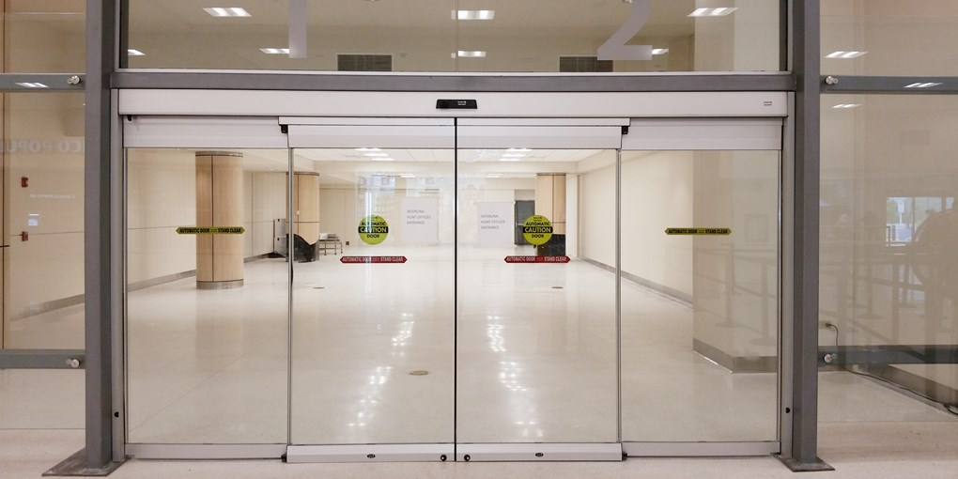

Description | Details
Operator Dimensions | (H) 150mm x (D) 123 mm
Power Supply | 100-240 VAC/50/60Hz
Power Consumption | Max. 250W
Opening / Closing – Speed | 1.7 m/s
Hold Open time | 0 – 60sec
Ambient Temperature | -20 Degree to +50 Degree
Opening time | 0.2 Seconds
Passage Speed | 30 peoples/minute
Glass | 12 mm thick Toughened Glass
Sensor | Motion Sensor for Auto Open and Close

